ID number………………………………………….(for office use)

Now that your child has nearly finished year 7, we would really like to find out how things have changed and what has stayed the same during secondary school.
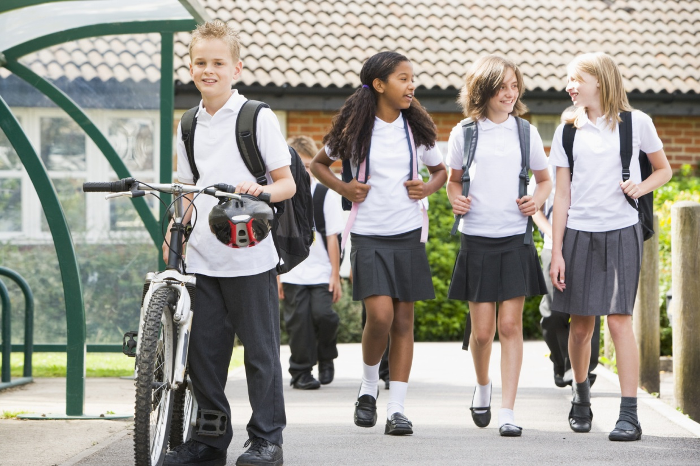

Your Child at School
My child has settled in well at secondary school…
- Academically | Strongly Disagree | Disagree | Not sure | Agree | Strongly Agree
- Socially (with peers) | Strongly Disagree | Disagree | Not sure | Agree | Strongly Agree
- Socially (with teachers) | Strongly Disagree | Disagree | Not sure | Agree | Strongly Agree
- To the new routine | Strongly Disagree | Disagree | Not sure | Agree | Strongly Agree
My child worries about…
- Being able to do the work | Strongly Disagree | Disagree | Not sure | Agree | Strongly Agree
- Other pupils | Strongly Disagree | Disagree | Not sure | Agree | Strongly Agree
- Is there anything else you think is important? | .............................................................................................................

How often does your child: | Never | Seldom | Some-times | Often | Always
- Try to learn something new even when they don't have to? | 1 | 2 | 3 | 4 | 5
- Try to find things to learn in class that are new and challenging? | 1 | 2 | 3 | 4 | 5
- Try to learn as much as they can about a new subject? | 1 | 2 | 3 | 4 | 5
- Try to work hard to understand what they are studying? | 1 | 2 | 3 | 4 | 5
- Try to show their teachers how clever they are? | 1 | 2 | 3 | 4 | 5
- Try to learn things only because they want to get a good mark? | 1 | 2 | 3 | 4 | 5
- Try to make sure their teachers know they have been working hard? | 1 | 2 | 3 | 4 | 5
- Try to get better marks than other children in their class? | 1 | 2 | 3 | 4 | 5
- Try to show they've learned more than their classmates? | 1 | 2 | 3 | 4 | 5
- Try to get more answers right than their classmates? | 1 | 2 | 3 | 4 | 5

How often do you: | Never | Seldom | Sometimes | Often
- Attend meetings with your child’s teacher offered by the school | 1 | 2 | 3 | 4
- Attend school events that your child is involved in | 1 | 2 | 3 | 4
- Insist your child does their homework | 1 | 2 | 3 | 4
- Help your child to do their homework | 1 | 2 | 3 | 4
- Encourage your child to read | 1 | 2 | 3 | 4
- Take your child on educational trips (e.g. museum, library, zoo) | 1 | 2 | 3 | 4

Your Child’s Behaviour
For each item below, please tick the number for Not True, Sort of True or Certainly True. It would help us if you answered all items as best you can, even if you are not absolutely certain. Please give your answers on the basis of your child’s behaviour over the last 6 months.
- Overall, do you think that your child has difficulties in one or more of the following areas: emotions, concentration, behaviour or being able to get on with other people? | No | Yes –  minor difficulties | Yes –  definite difficulties | Yes –  severe difficulties
- How long have these difficulties been present? | Less than a month | 1 – 5 months | 6 – 12 months | Over a year
- Do the difficulties upset or distress your child? | Not at all | Only a little | Quite a lot | A great deal
Do the difficulties interfere with your child’s everyday life in the following areas?
- Home life | Not at all | Only a little | Quite a lot | A great deal
- Friendships | Not at all | Only a little | Quite a lot | A great deal
- Classroom learning | Not at all | Only a little | Quite a lot | A great deal
- Leisure activities | Not at all | Only a little | Quite a lot | A great deal
- Do the difficulties put a burden on you or the family as a whole? | Not at all | Only a little | Quite a lot | A great deal
- Have you sought any help for learning, behavioural or emotional problems your child may have? | No | Yes, from friends/family | Yes, from teacher(s) | Yes, from GP
Yes, from other professional(s) (please specify)
……………………………………………………………………………………….

